Glossary: Mortal Chaos
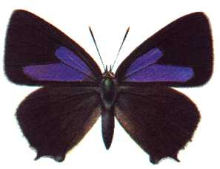
Page | Word | Definition
1 | Chrysalis  Silverweed & Red Campion  Proboscis  Unfurl  Incarceration  Iridescent  Yielding  Pigment  Coppice  Ash  Sapling | The hard shelled pupa of a butterfly.  Types of wild plants.  Protruding mouth part of an insect or animal (like an elephant’s trunk).  To unravel or stretch out.  To be enclosed or imprisoned.  Displaying a range of colours, like a rainbow.  Giving way under pressure.  Colour.  Dense growth of trees.  Ash is a type of tree.  A young being.

